Bekan School Enrolment Form 2025-‘26

Note: All forms must be completed in full and returned to the school, along with a Birth Certificate.

Name of Child (in full, as on Birth Certificate)
Date of Birth: ____________________________

PPSN: _________________

Address at which child resides:
Eir code:
Family email address for school communication:________________________________________

Nationality: ______________________________ Country of Birth:
If not born in Ireland, date on which child arrived in Ireland:
Mother’s Nationality: Father’s Nationality:

*If you change your mobile number during the school year please inform us immediately as it is vital to keep records up to date in case of an emergency.

Father’s Name:
Work telephone No: Mobile No:

Mother’s Name:
Work telephone No: Mobile No:

Guardian’s Name:
Work telephone No: Mobile No:

Is the child living with both parents

Religious denomination: _____________________

If your child was baptised please state where:_________________________
Date of baptism: __________________________ (Please include a copy of Baptismal Cert)
Did you child attend pre-school: ______

Name of pre-school:_________________________________

Has your child ever had a psychological assessment?
Has your child ever received a speech and language report?

Please give names, addresses and phone numbers of the people who have permission to collect your child from school. If there is any change in this routine please inform the school in writing.

Person who usually collects child(ren)

Phone
Phone

Phone
Phone

Parents and legal guardians are entitled to be consulted and informed about their child’s education and are entitled access to their child during school hours. If there is any change in this regard or if there is any other information which you think may be relevant it is very important that the school is informed immediately.

Other relevant information:

School Emergencies/Sickness/Unexpected Closures, etc.
The following information will be used by the school in the event of:
- Your child feeling sick.
- An emergency occurring while the school is in operation, making it necessary to close the school.
In such an emergency, it is advisable to ensure the safe return home of pupils.
- An unexpected closure of the school.

If your child gets sick, or the school has to close unexpectedly, etc and the school is unable to contact you, please provide the name, telephone number and address of two other people you nominate for us to contact. We will ask this person to come and collect your child/children.

Person the school will contact:

1 2

Tel/mobile: Tel/mobile:

Medical Emergency/Accident
That in the event of an emergency or accident, a member of staff will use his/her discretion and bring your child to a Doctor/Hospital. Every effort will be made to contact you.

I authorise that at their discretion, a member of staff may bring my child/children to a Doctor/Hospital if an emergency arises.

Signed (Parent/Guardian) ________________________________
List of Children ____________________________________
____________________________________
____________________________________
Family Doctor
Doctor’s Name _____________________________ Telephone No: _____________
Do your child/children have any specific medical condition (e.g. asthma, eyesight, hearing etc.)
or emotional problems which may affect your child at school?

It is the responsibility of parent(s)/guardian(s) to notify the school of any food allergies.
Do your child/children have an allergic reaction to medication or food?

Is there any other relevant information about your child/children which we should know?

Under GDPR the school is obliged to ensure that consent for the following has been obtained while your child is enrolled in Bekan National School.

I consent to my child’s participation in the RSE Programme

Parents Signature:

I consent to my child’s participation in the Stay Safe Programme

Parents Signature:

Screening Tests are carried out in the school on all children from Infants to 6th Class. I allow my child to do these tests.

Parents Signature:

During your child’s time in Bekan National School it may be necessary from time-to-time for teachers to carry out diagnostic testing with your child on an individual basis in order to help them in their educational development. I give permission for any necessary diagnostic tests to be carried out with my child.

Parents Signature:

I give permission for my child to use/participate in online learning as part of the school’s ‘Blended Learning Programme’.
Parents Signature:

I give permission to allow my family details (name, address, date of birth, etc.) to be given to agencies such as HSE (school nurse, doctor, dentist) and Department of Education (pupil online data base).

Parents Signature:

I acknowledge that I have read and accept the School’s General Policy, Code of Behaviour, Anti-Bullying Policy, Substance Use Policy, Internet Use Policy and RSE Policy of Bekan National School all of which are available to download from the school’s website (www.bekanschool.ie) Hard copies are available on request from the school office.

I wish to enrol my child ________________in Bekan School.
I declare the above information to be correct and understand that it will be treated as confidential.
Signed:_____________________________ Date: _________

Please ensure that you have included a Birth Certificate and Baptismal Certificate (if your child was baptised) with this form. These documents will be photocopied and returned to you.

St. Joseph’s National School
Scoil Náisiúnta Naomh Seosamh
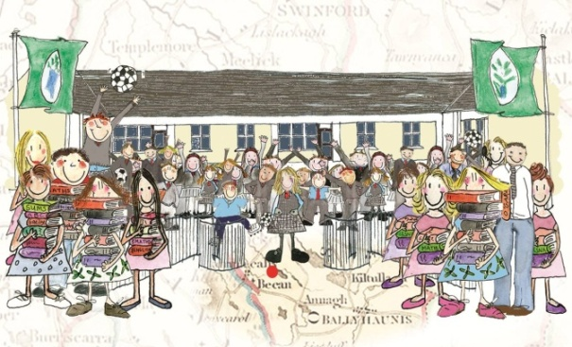
Uimhir Rolla: 13659I Cill Bheacain, Clár Cluinne Mhuiris Co. Mhaigh Eo
Office: (094) 9380311 Bekan, Claremorris, Co. Mayo
F12 RP44

Charity No: 20129637

Dear Parents/Guardians,

The Department of Education and Science has introduced guidelines and procedures for all schools in relation to Child Protection and Welfare. These guidelines promote the welfare of all children and are to be welcomed.

The Board of Management of Bekan National School has adopted these guidelines as school policy. Consequently if there is a matter of concern in relation to abuse of children we are obliged to report this to the local HSE Social Work Dept. They will assess the case and provide the necessary advice for the school and support for the child/family concerned.

All of the teaching staff have received training in the implementation of the Children First Guidelines and the Board of Management has appointed a Designated Liaison Person [Principal] and a Deputy Liaison Person [Deputy-Principal] who will have responsibility for liaising with staff and HSE personnel in regard to issues which may arise under the Guidelines.

The complete Children First guidelines can be accessed at
http://www.dcya.gov.ie/documents/child_welfare_protection/ChildrenFirst.pdf

Yours sincerely,
Marie McDonagh

(Please sign and return the section below to the school)

=====================================================

Child Protection and Welfare Guidelines
I/We have read the letter regarding Child Protection and Welfare. I/We understand and accept its contents as an integral part of the school’s enrolment policy.

Signed: ………………………………………(Parents/ Guardian)
Print name________________________

